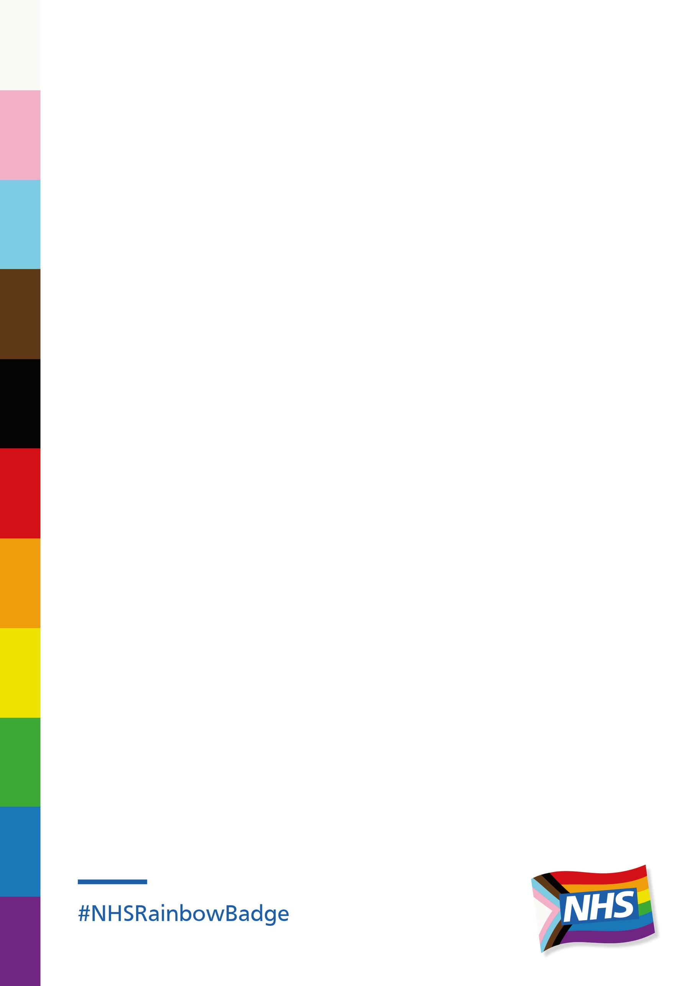

NHS Rainbow Badge Assessment

The Rainbow NHS Badge was developed and led from Evelina London’s Children Hospital - part of Guy’s and St Thomas’ NHS Foundation Trust. It was created to be a way for NHS staff to demonstrate that they are aware of the issues that LGBT+ people can face when accessing healthcare.

The original model emphasised that wearing a badge is a responsibility. It provided basic education and access to resources for staff who wanted to sign up to the project. The information provided outlined the challenges that LGBT+ people can face in relation to accessing healthcare and the degree of negative attitudes which are still found towards LGBT+ people.

NHS England have commissioned a collaboration, consisting of the LGBT Foundation, Stonewall, the LGBT Consortium, Switchboard and GLADD, to deliver Phase 2 of the NHS Rainbow Badge scheme.

This next phase has moved to an assessment and accreditation model and allows Trusts to demonstrate their commitment to reducing barriers to healthcare for LGBT people, whilst evidencing the good work they have already undertaken.

During the development of the model, consultation has taken place with patients and professionals over the course of 5 focus groups. We have also conducted a pilot with 10 NHS Trust taking part and providing feedback into the assessment process

The assessment structure will involve the following processes:

1. Policy review
2. Staff survey
3. Patient survey
4. Services Survey
5. Assessment document

The following subjects will be assessed:

* Clinical service provision: Including Perinatal, Fertility, Oncology, Laboratory, Sexual Health & Gynaecology
* Mental Health & Learning Disability service provision
* Workforce inclusion
* Leadership
* Sexual Orientation, Gender and Trans Status monitoring
* Facilities
* Engagement

The information from all aspects of the assessment process will be reviewed and the Trust will receive a graded award reflecting their current LGBT inclusion work. This will be either Bronze, Silver or Gold.

In addition to the award the Trust will also receive a comprehensive feedback report and action plan, this is designed to help Trusts achieve the next level and should facilitate meaningful change.

We have funding to support 40 Trusts through the process at no cost to the individual trust. Applications to be involved can be made by completing the Expression of Interest form