

**request-663578-1ef5d016@whatdotheyknow.com**

**19th May 2020**

Dear Sirs

**Freedom of Information Request Reference No: 202005115**

Thank you for your request for information about Gas pipes within a common area of a multiple building.

Your request was received on 11th May 2020and I am dealing with it under the terms of the Freedom of Information Act 2000 (the Act).

I can confirm that the Health and Safety Executive holds the following information:

1. **Details on who is responsible for live pipes situated in common areas of a multiple building.**

The industry standard for Gas in Multi Occupancy Buildings is IGEM G 5 which lists the responsibility for the installation and operation of sections of the gas supply system as follows:

|  |  |
| --- | --- |
| Description | Responsibility |
| Network, including the emergency control valve (ECV) and any PRI upstream of the ECV | The Gas Transporter |
| Primary meter installation | The Meter Owner |
| Installation pipework (including secondary and sub-deduct meter installations) | Pipework owner (for example the occupier, landlord / housing association) |
| Appliance connector and appliance | Appliance owner (for example the occupier, landlord / housing association) |
| Ventilation ducts, meters etc | Building owner |

The layout of the gas system within a multiply occupancy building will determine on who is responsible for the live gas pipes situated within the common areas of the building.  If the “Valves in individual dwellings act as emergency controls and meter controls” or the Emergency Control Valves (ECV) is at the door to each flat, as shown in Figure 7(a) below, the pipework within the common areas is **service pipe** which the gas transporter would be responsible for.  Any installation pipework from the ECV to the gas appliance would be under the responsibility of the pipework owner – the occupier, landlord or housing association.

If the layout of the gas system is similar to Figure 7(b) below, there is an emergency control valve at floor level and additional emergency controls at flat level, then the Gas Transporter responsibility will end at the ECV at floor level and the pipework within common areas is Installation Pipework, which would fall to the Pipework owner (for example the occupier, landlord / housing association)

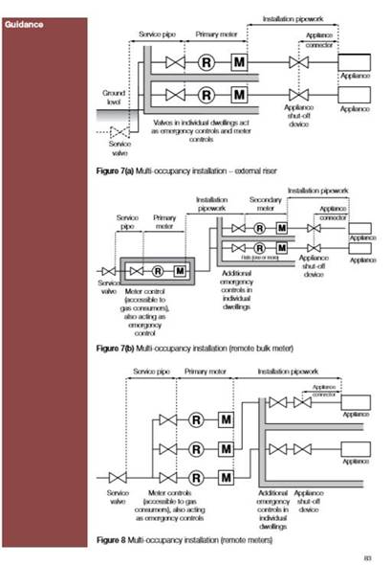

The figures are from page 83 of the Approved Code of Practice for the Gas Safety (Installation and Use) Regulations which can be downloaded at <https://www.hse.gov.uk/pubns/priced/l56.pdf>

This information can be disclosed and copies are enclosed.

The information supplied to you continues to be protected by the Copyright, Designs and Patents Act 1988. You may re-use this information (not including logos) free of charge in any format or medium, under the terms of the [Open Government Licence](http://www.nationalarchives.gov.uk/doc/open-government-licence/version/3/). Further information is available on the National Archives website. ([Open Government Licence - Re-using Public Sector Information](https://www.nationalarchives.gov.uk/information-management/re-using-public-sector-information/uk-government-licensing-framework/open-government-licence/)).

Information you receive which is not subject to Crown Copyright continues to be protected by the copyright of the person, or organisation, from which the information originated. You must ensure that you gain their permission before reproducing any third party (non-Crown Copyright) information.

If you have any queries about this letter, please contact me. Please remember to quote the reference number above in any future communications.

If you are unhappy with the decisions made by HSE you may ask for an internal review within two calendar months of the date of this letter by writing to me.

If you are not content with the outcome of the internal review you have the right to apply directly to the Information Commissioner for a decision. The Information Commissioner can be contacted at:

The Information Commissioner’s Office

Wycliffe House

Water Lane

Wilmslow

Cheshire

SK9 5AF

Tel: 0303 123 1113

Email: casework@ico.org.uk

Website: https://ico.org.uk

Yours sincerely

Cameron Hadwin