WAYFARER P50
Power on light (green changes to red if power low)
On/Off button
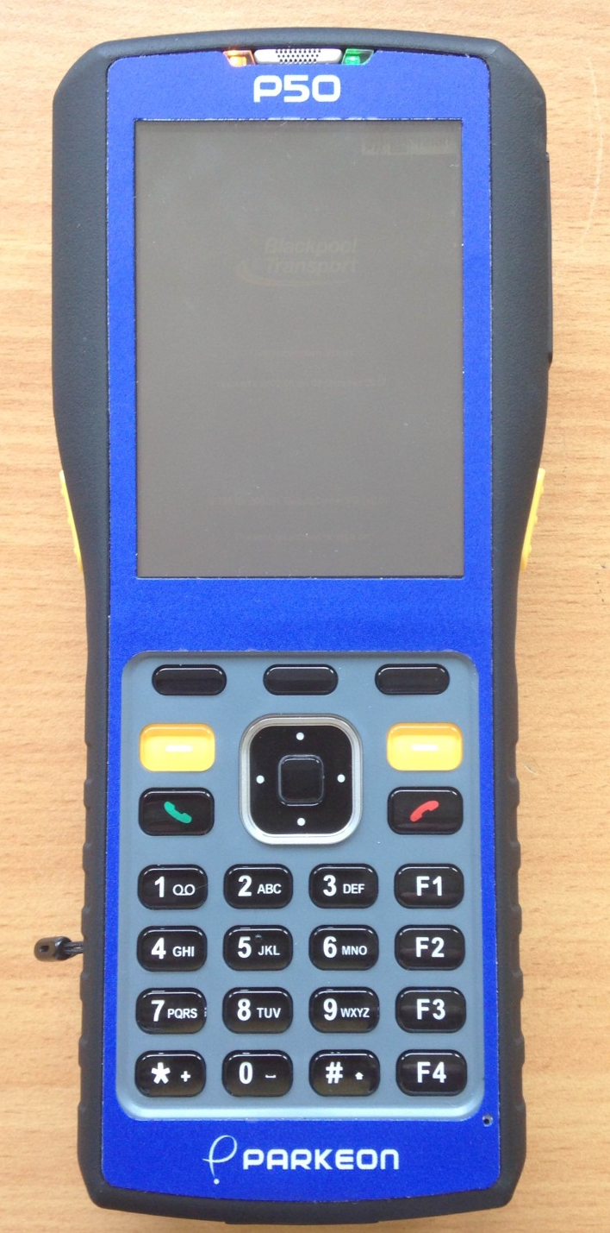
Cancel /back button
Top & Bottom white dots allow you to move up & down the fare table changing the boarding stage
Operators Menu
Left & Right white dots allows you to move up & down the fare table without changing the boarding stage
F1 will select the number of the Day
Touch screen display. Allows you to select products and destinations
Reset button using stylus
Paper feed from printer

Enter button
Plug for charger/power supply

None of the other buttons are functional at this time
By pressing the on/off button on top of the P50 the machine will activate (this will take approx. 2 minutes)
Check top right hand of the screen for time, battery life and GPS signal.
Place your smart card on the underside of the P50, at the printer end.
Drivers sign on screen will display. (Your staff number will be pre entered) Enter your pin number and then press enter.

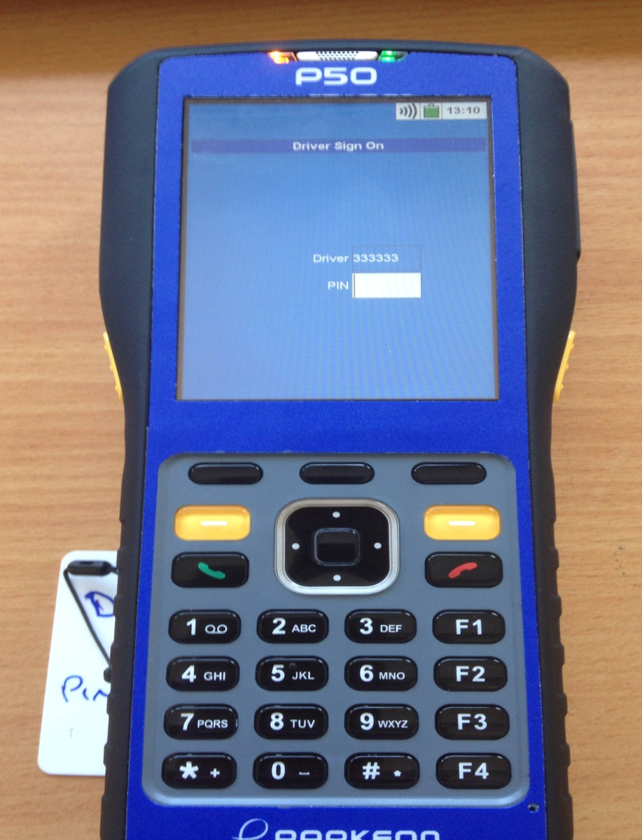
Smart card
Pin No
Staff No
Pre entered

GPS

Battery life
Time display

New screen
Will ask Tram Checked, by tapping the white box yes will be entered onto the screen. Press the enter button
You will now be asked for your duty number. Type in your duty number and press the enter button.
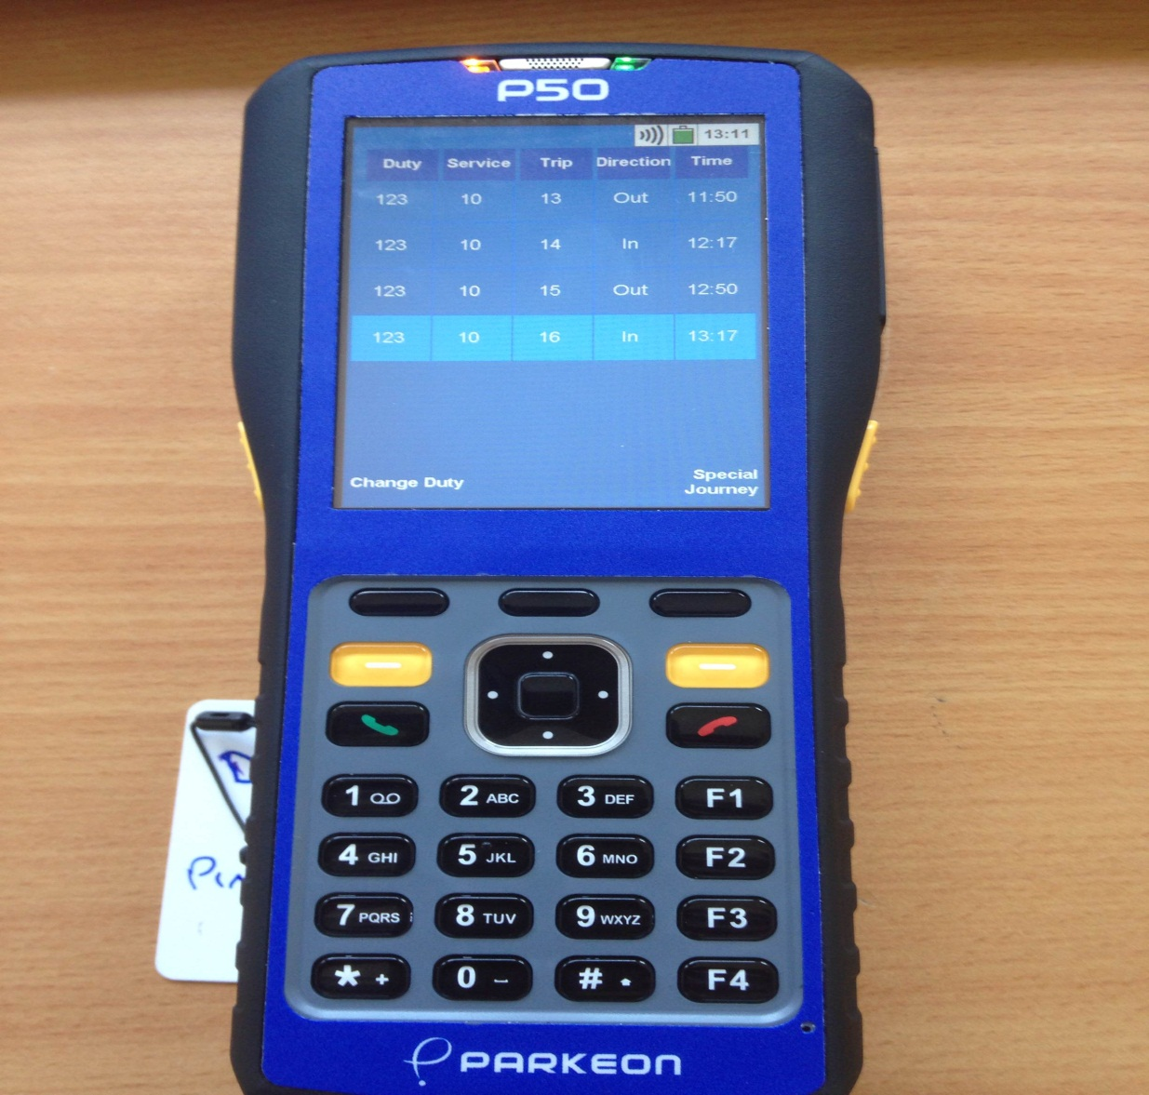
The next screen will bring up the details if your duty:
Duty number
Service
Trip number
Direction
Time of departure
If the information on the screen is correct, press the enter button.
If any of the information is incorrect, press Change Duty and re-enter your duty number
The next screen confirms your details, press the enter button or continue.
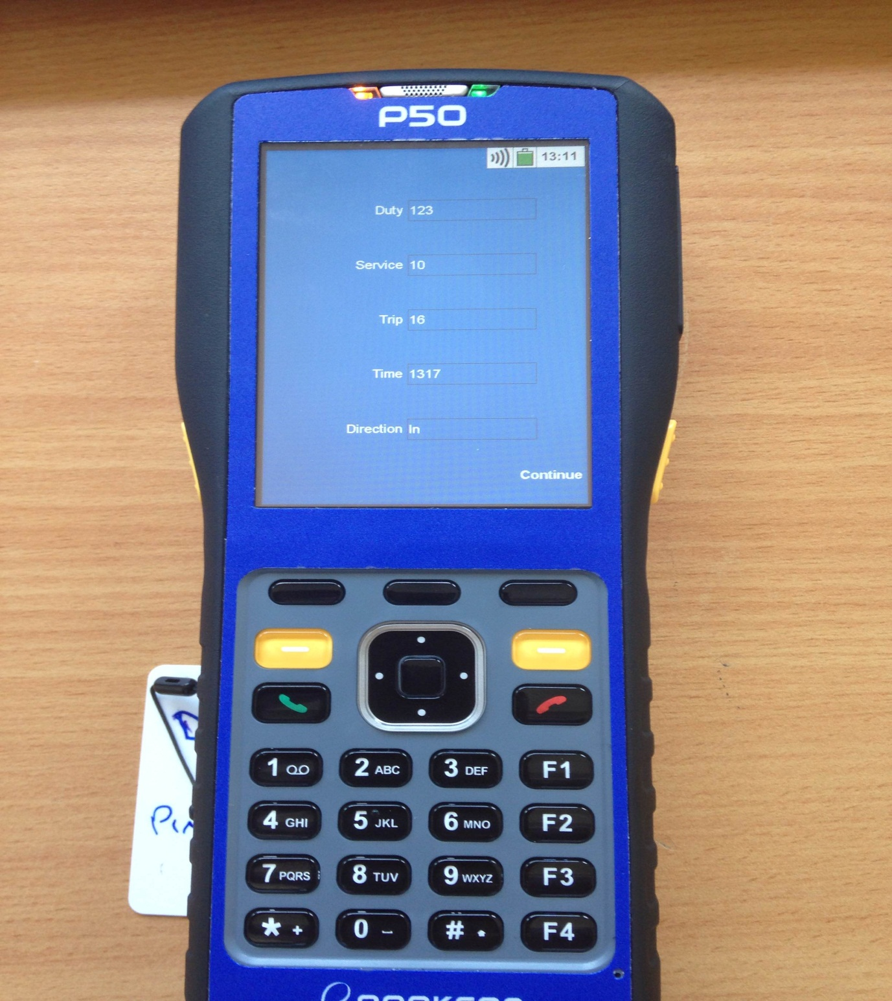

You will now be asked to remove your smart card.TheP50 is ready to be used.

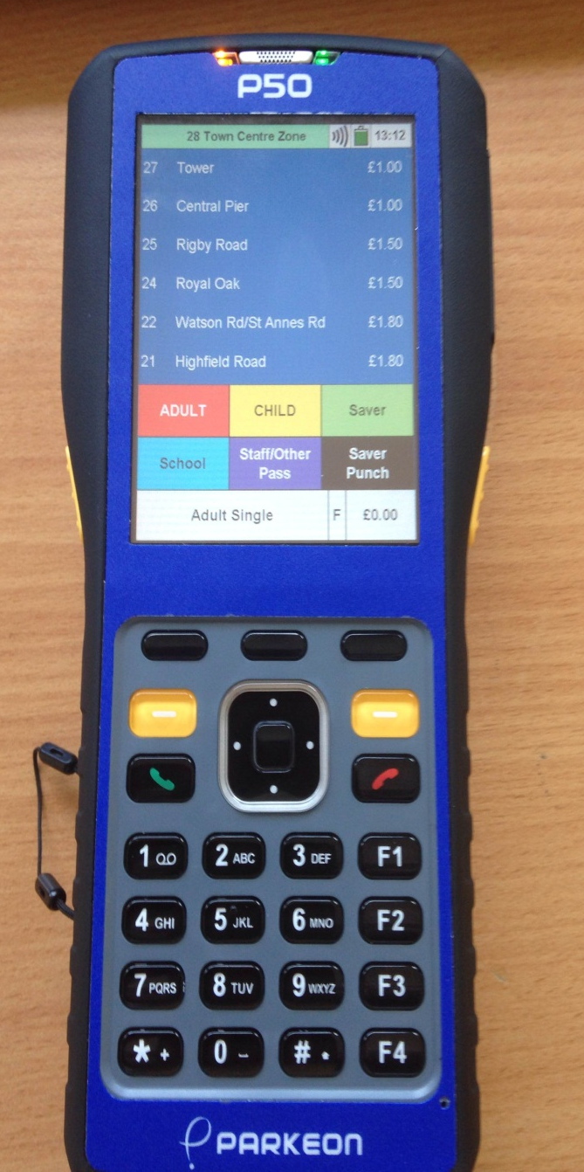
Total cost of ticket
Alighting stages 6 backwards
Manual fare stage button backwards
Manual fare stage button forwards
Alighting stages 6 forward
Class of ticket to be issued
Alighting Stages
GPS working/Not Working
Battery level / time

Boarding Stage
To issue the ticket press the alighting stage. To remove the ticket pull up and across
The fare/boarding stage (at top of the screen in Green) has to be moved manually. This is achieved by using the white dot on the right of the enter button (forwards) white dot on the left of the enter button (backwards). Alighting stages are moved on in groups of six. This is achieved by selecting the forwards and backwards buttons above and below the enter button.
Just press the screen against the alighting stage to issue the tickets.
Always make sure that the white box at the bottom of the screen is displaying the correct ticket classification.
Screen key pad for type of tickets/passes
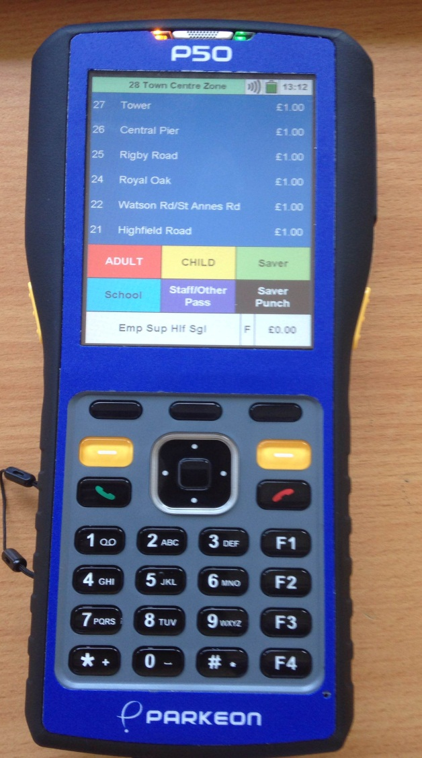
Adult fare default setting
Staff Passes /Other Passes, Add-on fares and ENCTS Not working

School passes
Child button will change fares from adult to child fares. Press this button twice for Emp sup hlf sgl
Saver button put up screen for paid passes, PROMO-U-16£1.00,Dog,New Deal, illumination Tours, Day Saver 1,Day Saver 2,Heritage Tours, Resort Passes, Some of these have 2nd sub screens for the different priced/types Daily, Weekly, Monthly Family
Saver Punch registers all the different types of passes which are pre-paid i.e. All those issued in the Saver screen inc.plus Bus

Ticket Issue
If you require the machine to total the fare value of a transaction, press the white box at the bottom of the screen displaying £0.00 until it displays £0.00T the total transaction will show in the white box.
For group ticketing i.e. one ticket for multiple passengers (all passengers must be alighting at the same destination) Press the white box with displaying £0.00 until the box turns Red showing £0.00+
Press the required ticket types, press enter a sub menu will show, press group issue, one ticket will be issue for multiple passengers.
If for any reason at this stage the passenger wish to have individual ticket press issue instead of group issue.

Group tickets can only be issue for adult and child passengers. Tickets for Dogs, Day Savers Etc. must be issued individually.
The Calculator facility
To calculate the change due to a passenger, after the tickets have been issued, enter the amount tendered (using the key pad), a sub menu will show, press calculate change the amount tendered, sale value and the change required will be shown..

CONCESSIONARY TRAVEL
Any senior citizens with a valid Now Card travelling on our service before 09.30 Monday to Friday Pays the normal fare.
Between 09.30hrs and 23.00 hrs. (Monday to Friday) all English Now Card holders travel FREE on production of a valid Now Card.
Fridays only after 23.00hrs until end of service, English Now Cards travel FREE as this is classed as the start of the Weekend.
Saturdays, Sundays and Bank Holidays NoWcard holders travel Free

Disabled Now Cards
If traveling before 09.30 Monday to Friday, a PAID fare of 0.50p is required, for any destination on that route. (This is produced the same way as issuing a NoWcard Ticket, if unable to do so then issue an Add-on ticket for 0.50p).

Driver/Conductor Menu

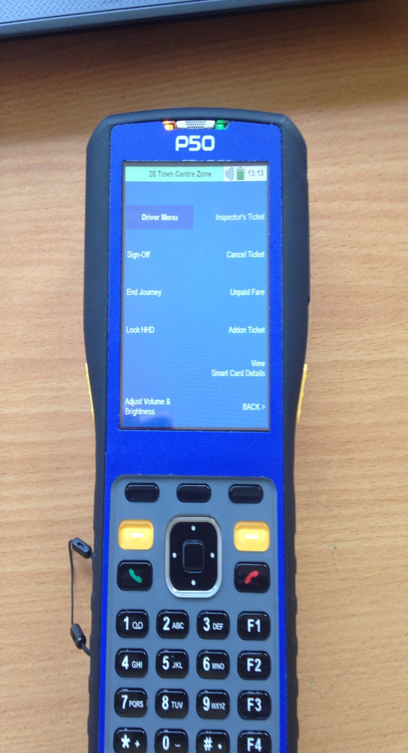
Back
Adjust volume & brightness
End Journey
Lock ETM
Sign Off
View Smart card details
Add-on ticket
Unpaid fare
Cancel/Annul ticket
Inspector ticket

The drivers menu is accessed by pressing

Driver/Conductor Menu
Conductor Sign Off; When your due to finish your duty place your smart card on the underside of the P50 near the printer end, It will then ask you if you want to confirm Sign Off, press yes if you wish to do so and no if you do not. This will produce your way it is advisable to keep your waybills as there is no longer a depot reader
If for any reason the previous user has not signed off, the machine can still be used. Press Force Sign Off this will allow you to sign on. There will be no waybill issue for the previous conductor.
End journey
Press End Journey and follow the instructions.
Lock ETM
This will lock your P50, but you will have to use your smart card to unlock it when you use it next.
Adjust Volume & Brightness
When pressed you have the choice to adjust the above.
Right side of screen
Inspector tickets
This is for the Inspectors only
Cancel/Annul ticket
The first screen will show you the tickets you have just produced and then by choosing the ticket you wish to Cancel/Annul and pressing the chosen one it will produce your Cancelled/Annulled ticket (You only have two minutes to do this).
Unpaid Fare
This function allows you to issue an Unpaid Fare Ticket. Enter the value in pence, and then press the Enter button. Remember to fill in the details and keep your half of the ticket.

Add-on Ticket
This will allow you to issue an Add-on Ticket. Enter the value in pence, and then press the Enter button.
There is a second sub screen on this page which will do the following
View Cash Totals
Produce a receipt for invalid smart cards
Insurance Ticket This can be used in the event of an incident should the third party require the company insurance details etc. This does not replace the normal accident reporting procedure.

Late Annulments
Should you need to issue a late annulment, you must collect the ticket, along with the customer’s name and address and then submit them together with a general report form.
If a customer requires a change of ticket then this should then be issued.
You will not be issued with credit, if the customer’s name and address are not submitted in the correct form.
End of Duty

