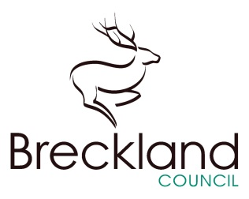

**Breckland Council**

Elizabeth House

Walpole Loke

Dereham

Norfolk

NR19 1EE

Date: 08/04/19

Our reference: BFOI-006835

Your reference:

Dear Lady Fleming

**FOI Council Tax Liability Orders. Ref: BFOI-006835**

Your request for information has now been considered and Breckland District Council’s response is below.

Please see attached Spreadsheet

If you require any further information, or are not happy with the information that you have been provided with or if you are not happy with the way that your request has been handled you may request an internal review. Please contact the Freedom of Information Team at:

If you have any queries or concerns then please contact us at:

Freedom of Information Team

Breckland District Council

Elizabeth House

Walpole Loke

Dereham

NR19 1EE

[feedback@breckland-sholland.gov.uk](mailto:feedback@breckland-sholland.gov.uk)

Further information is also available from the Information Commissioner at:

Information Commissioner's Office

Wycliffe House

Water Lane

Wilmslow

Cheshire

SK9 5AF

The link below will refer you to the ICO website, which may be of use:

[www.ico.org.uk](http://www.ico.org.uk)

Yours sincerely

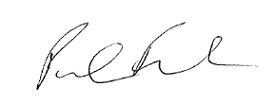

**Peter Fuller**

**Statutory Information Officer**

**Breckland District Council**

**01362 656 870**