Tel: 0151 252 3000
Email: foi@liv-coll.ac.uk

Dear Josie,

This is to acknowledge your FOI request of the 7th October 2016.
Your request has been passed to the appropriate Manager(s) within the College and an answer will be supplied within the statutory period.

Yours sincerely
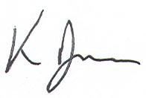

Ken Ryan
Director of Information Technology
The City of Liverpool College

