Head of Revenues and Benefits
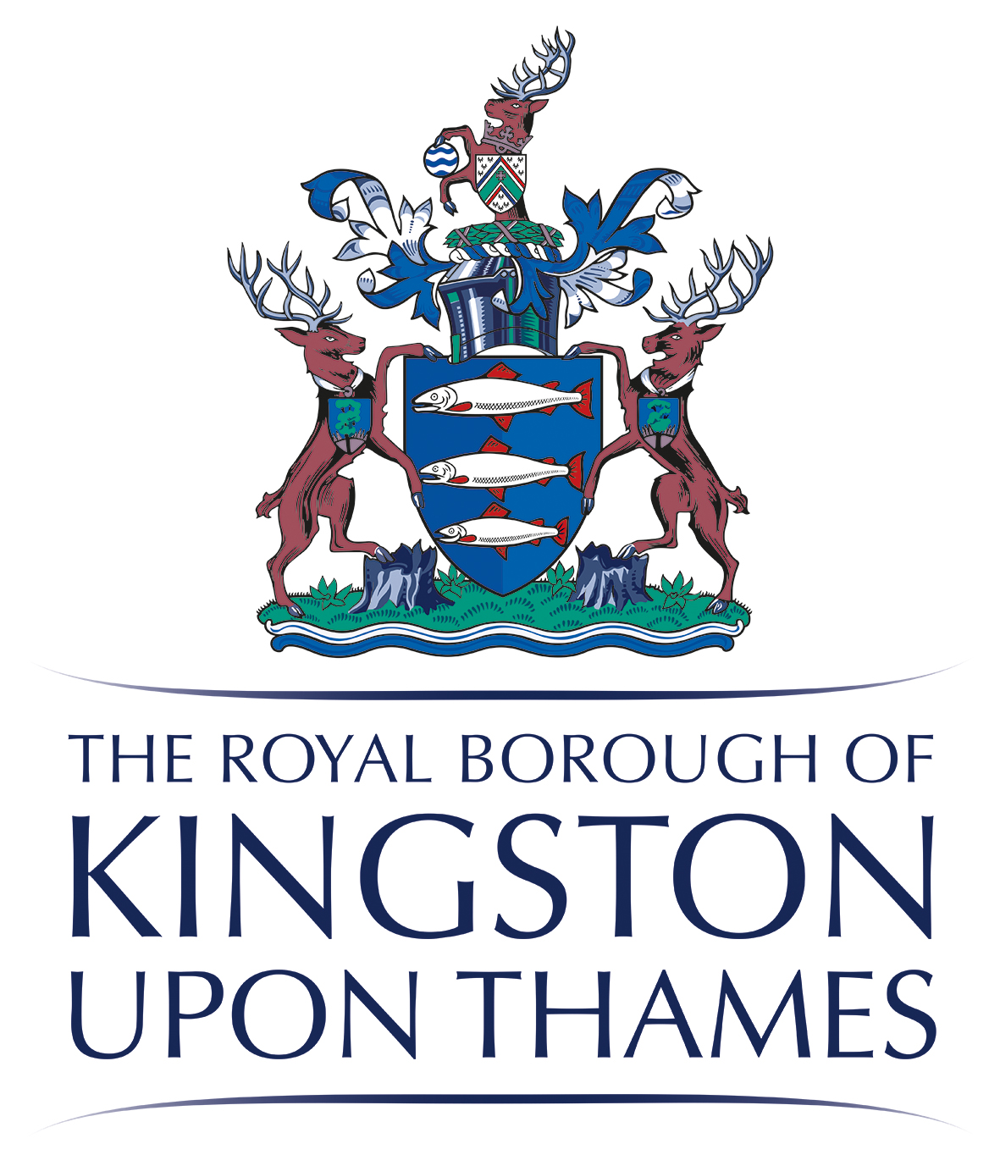
Mary Tam

My Ref: FOI Request

Enquiries to: Mr A Faulkner

27 May 2016

Mr Tom Murray

Dear Mr Murray

Freedom of Information Request

I refer to your request for information which has now been considered and the information you require is set out below.

If you have any concerns or queries about the handling of your enquiry then please contact the Records Manager & Data Protection Officer, Royal Borough of Kingston upon Thames, High Street, Kingston upon Thames, KT1 1EU, telephone 020 8547 5757, Email: foi@rbk.kingston.gov.uk

Further information on the Act is available from the Information Commissioner at:
Information Commissioner’s Office
Wycliffe House
Water Lane
Wilmslow
Cheshire
SK9 5AF

Telephone: 01625 545 700 www.informationcommissioner.gov.uk

In your request you asked for:

‘What was your recovery rate for revs & bens debt collection for the last 3 financial years?’

I have assumed that you require the in year collection figures for council tax and business rates by financial year.

Revenue Type | In Year Collection Figures by Financial Year (%)
 | 2013/2014 | 2014/2015 | 2015/2016
Council Tax | 98.6 | 98.5 | 98.9
Business Rates | 97.7 | 98.6 | 98.9

If I can be of any further assistance please don’t hesitate to contact me.

Yours sincerely,

Antony Faulkner
Revenue Manager

.

