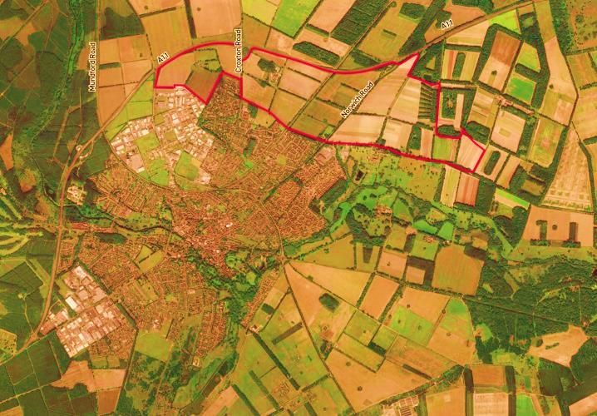

Greater Thetford Development Partnership
Board

2nd December 2.30pm- 4.30pm
Carnegie Room
Cage Lane
Thetford
Norfolk
IP24 2DS

AGENDA
 | Item | Lead
1 | Approval of Minutes (02/10/15) | Anna Graves
2 | Breckland Bridge Presentation (Progress) | Julie Kennealy / Nigel Robson
3 | MTF Bids | Maurice Howard
4 | Communications | Sarah Barsby
5 | Independent Chair (Progress) | Julie Kennealy
6 | Community Sub Group (Progress) | Rob Walker
7 | Planning and Projects Sub Group (Progress) | Richard Doleman
8 | Inward Investment Sub Group (Progress) | Julie Kennealy
9 | Next Steps | Anna Graves to summarise
10 | AOB
11 | Date of Next Meeting and Future Meetings | Anna Graves

