Sam Crawford
[By email: request-229132-e7601991@whatdotheyknow.com]

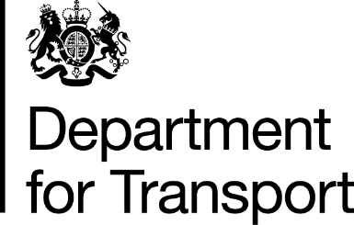

P Parr
Information & Security Division
Department for Transport
Zone D/04
Ashdown House
Sedlescombe Road North
St Leoanrds on Sea
East Sussex
TN37 7GA

Web Site: www.dft.gov.uk

Our Ref: F0011688

17 November 2014

Internal Review of Freedom of Information Act Request – F0011688

Dear Sam Crawford,

I am writing in response to your email dated 10 November 2014 seeking an update on your Internal Review request which you originally made to the Department on 7 October 2014.

I would like to apologise for the delay in providing you with a full response to your complaint. This is due to staff resourcing issues in the Franchise Design team.

I can confirm that I am carrying out an independent Internal Review of the Department’s handling of your request, and that I hope to complete my review and issue my response by no later than Tuesday 25 November 2014. If there are any further delays I will keep you informed.

In the meantime, I can advise you that some of the information which you requested – relating to performance targets – has now been published on the Department’s web-site as part of the Franchise Agreement between the Secretary of State for Transport and London & South Eastern Railway Limited. You can find this information at the following link:

https://www.gov.uk/government/uploads/system/uploads/attachment_data/file/375402/lser-franchise-agreement.pdf

I draw your attention in particular to Schedule 7 on page 248 and following; and to Appendix 1 to Schedule 7.1 on page 267 and following.

Once again I apologise for the delay and assure you that we will make every effort to provide you with a substantive reply by 25 November.

Yours sincerely,

P Parr
FOI Advice Team

