PATIENT
TRANSPORT
Booking Ready
Guide

To book ready in advance (the day before) call control
To book ready on the day use this guide

This guide is to help with booking patients ready.
https://clericwest.g4spts.com

STEP 1. To enter the transport-booking site, go through the St Georges intranet.
Type in the following web address in the browser
https://clericwest.g4spts.com. The below screen will appear.

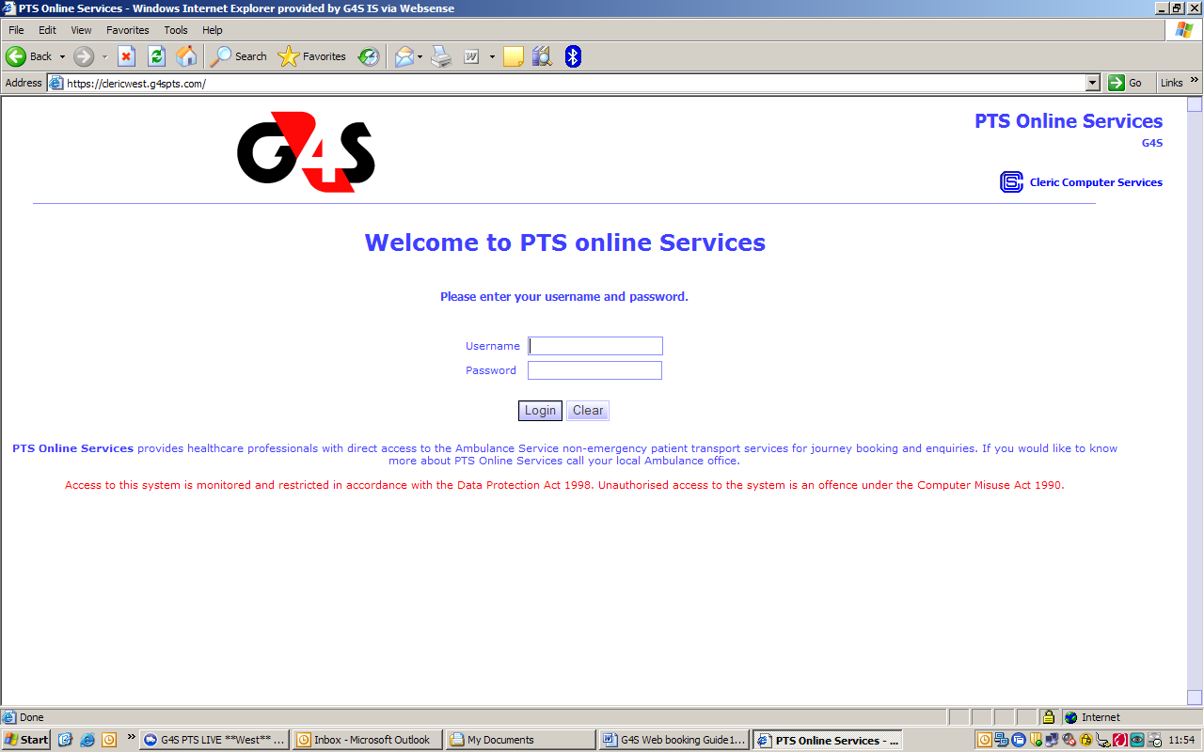

Enter you username and password (this is obtained from transport).

Click on the Day Control button on the left hand side. This will give you one other option:
Book Ready.

The below screen will appear.

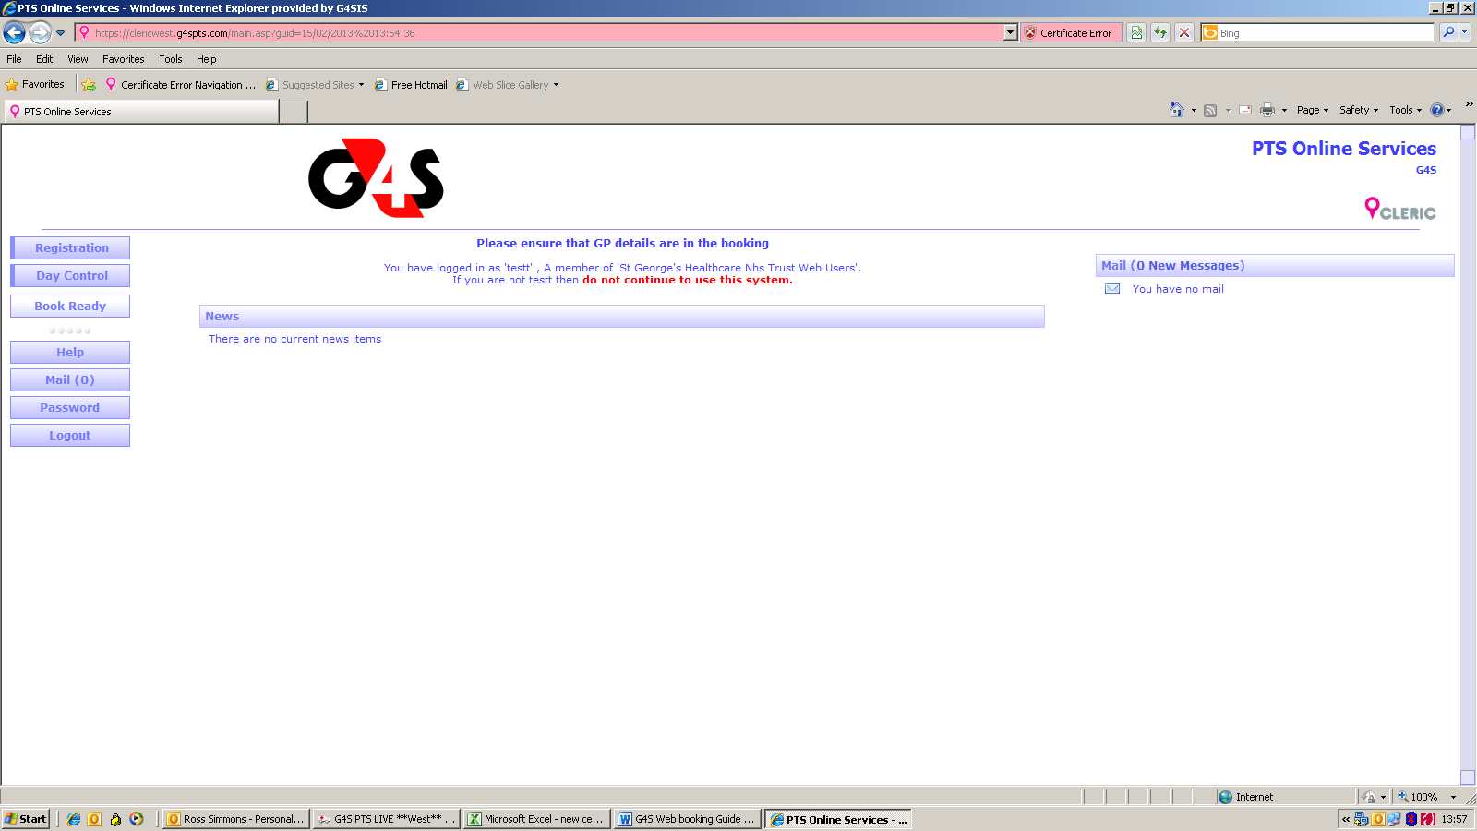

Select book Ready and the book ready search screen will pop up.

The below screen will appear

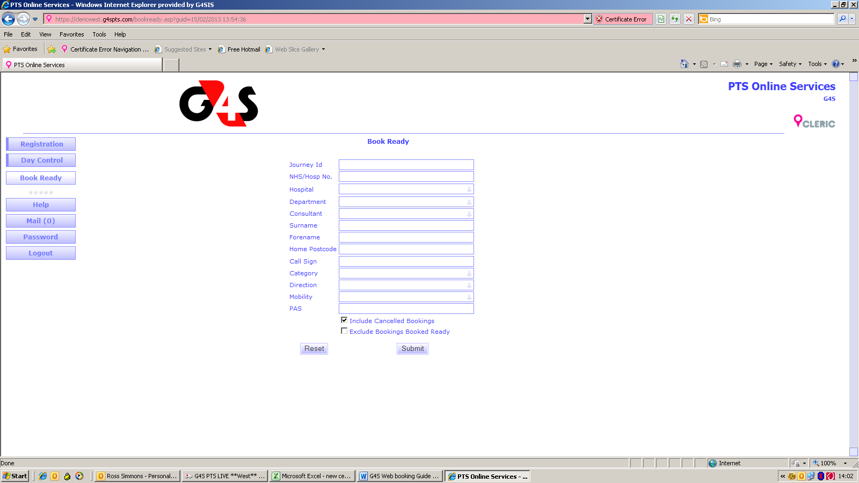

Enter the patient’s Surname or your journey I.D number.

This should bring your patient. Make sure this is the correct journey.

The below screen will appear.

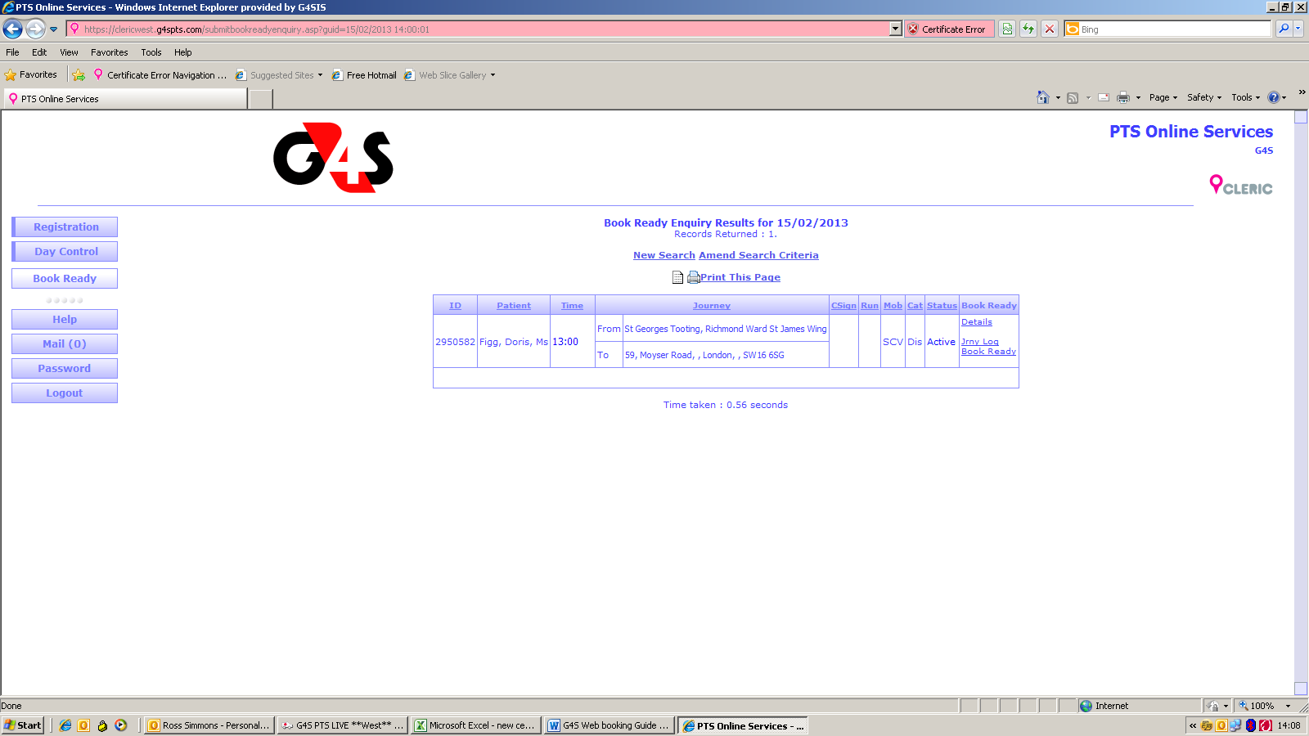

If the details are correct then along the right hand side there is option that says book ready, click on this and the screen below will appear.

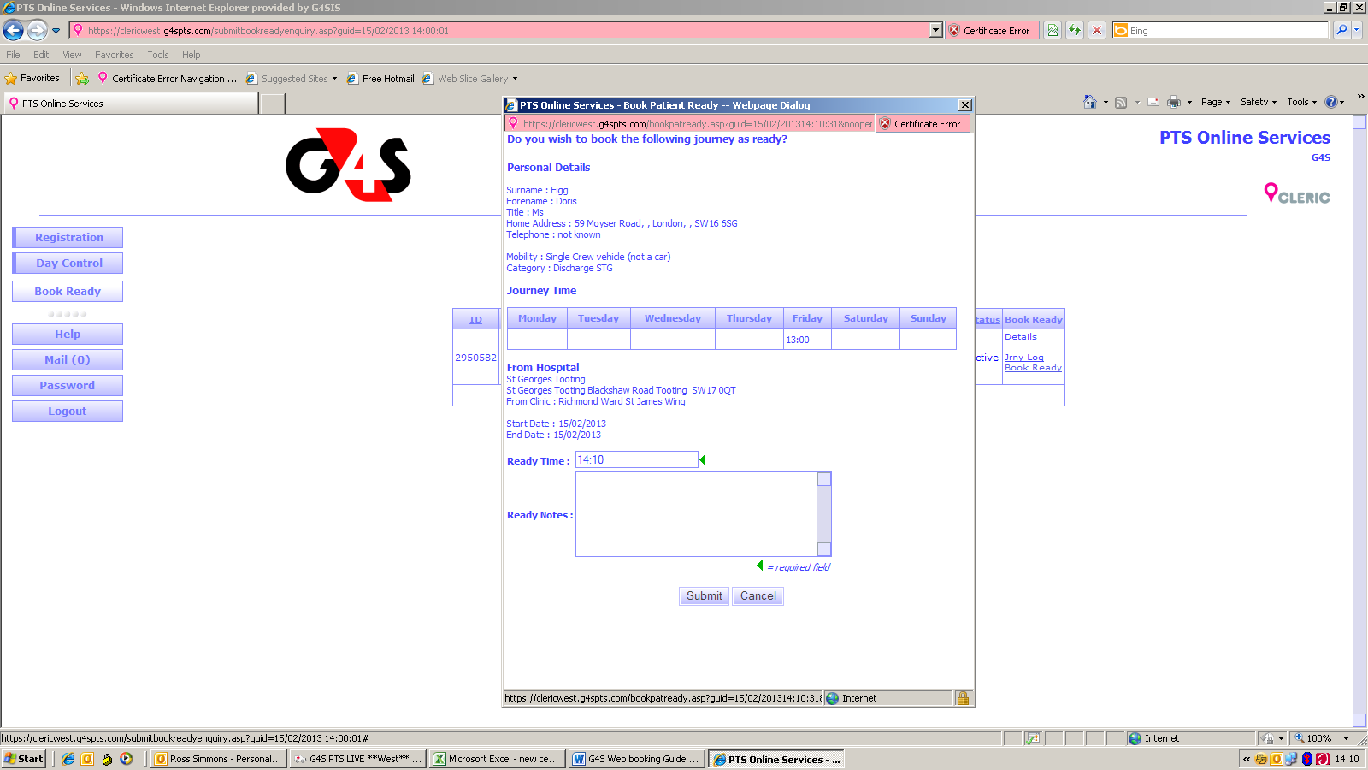

In the ready time box type in the patient ready time and click submit and the below screen will appear.

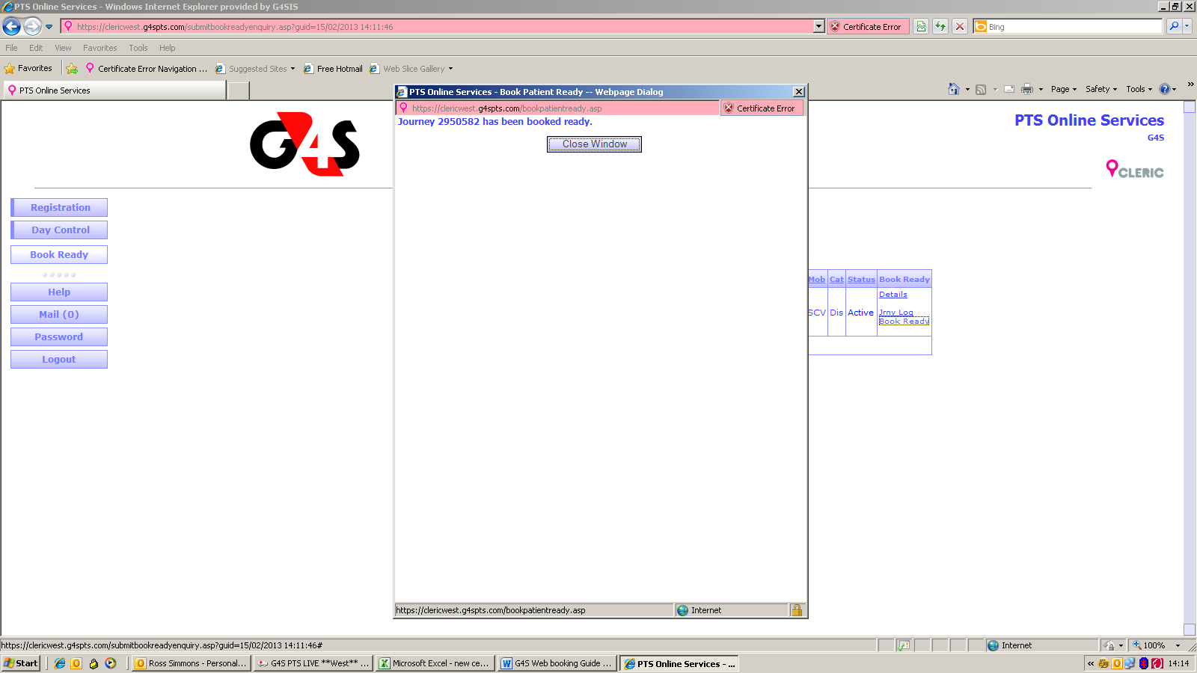

This confirms the patient has been booked ready. If you click close window the below screen will appear showing a RED R next to the time.

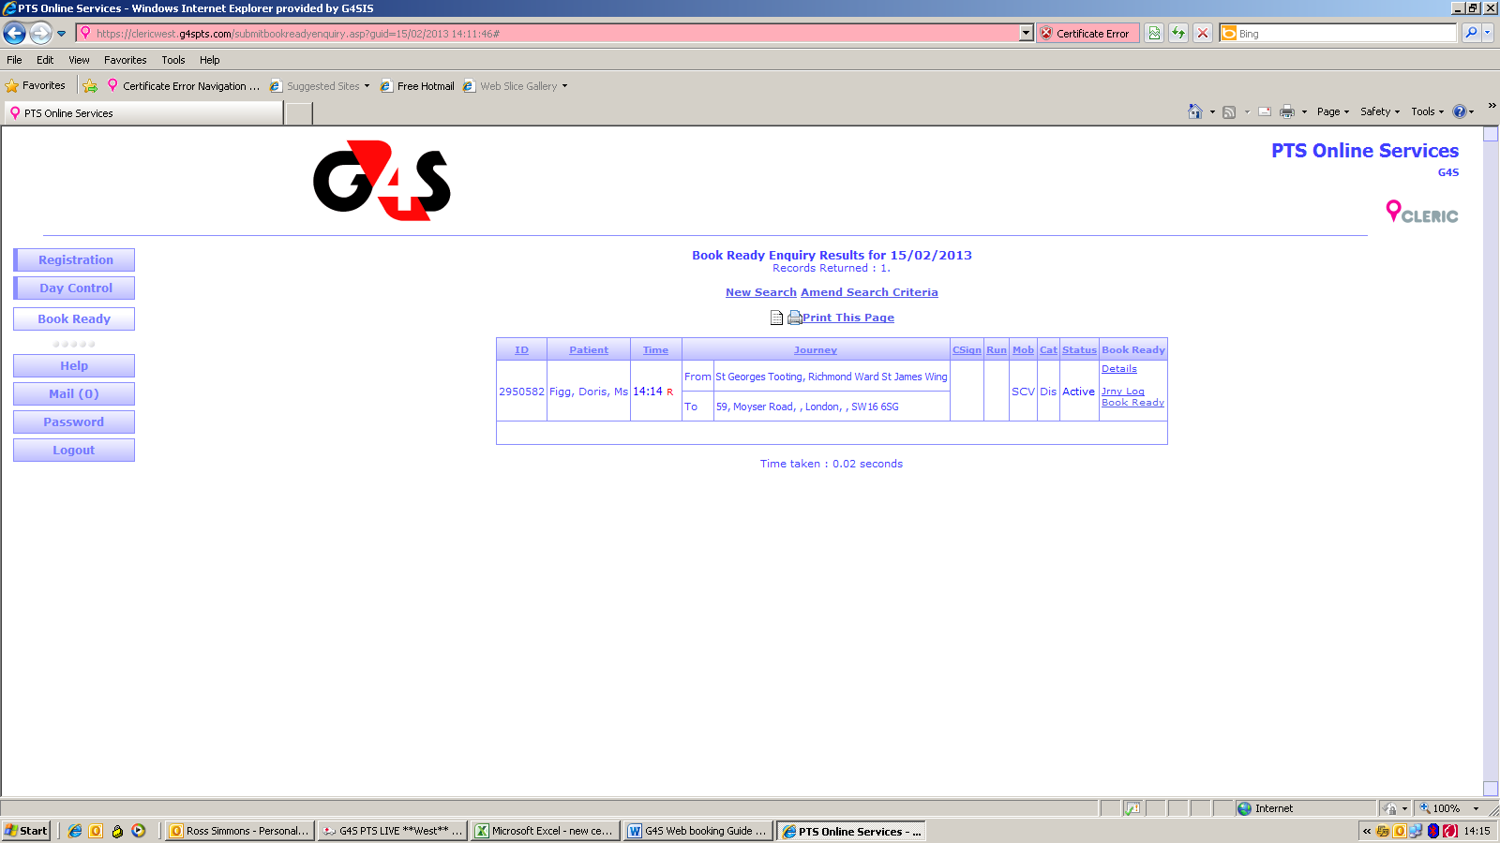

After this stage you can log out, your book ready is complete.

Key Points To Remember When Booking Patients Ready.

- All Discharges and transfer to be booked ready via the web system.

- Patients can only be booked ready on the day of transport. (If you want to book patients ready the day before you must do this via St George’s control on 6218).

- Long distance journeys need to be booked 24 hours in advance via Control. Confirm with control by phone when these patients are booked ready.

- Long distance journeys including admissions for weekends need to be booked ready by Friday via Control. Before the 16.00 cut off

- Patients can be booked ready on the day up until 20.00.

- Unless there is a system failure all patients being booked ready must be via the web. (If there is a system failure then patients can be booked ready via St George’s control on 6218).

