

# ‘*The Euro Crisis’*

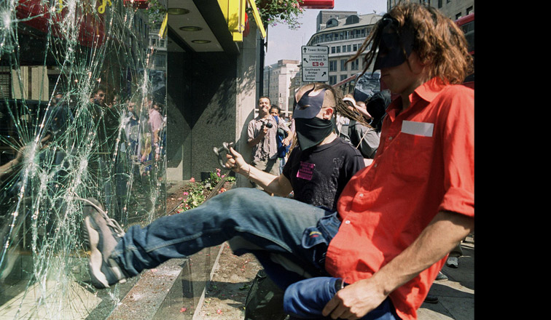

# ‘*Riots and social unrest’*

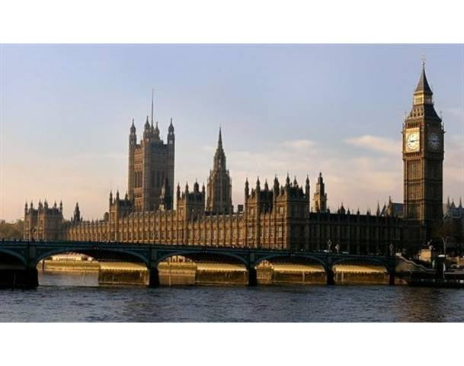

***‘Politicians expenses and misconduct’***



***‘Phone hacking’***

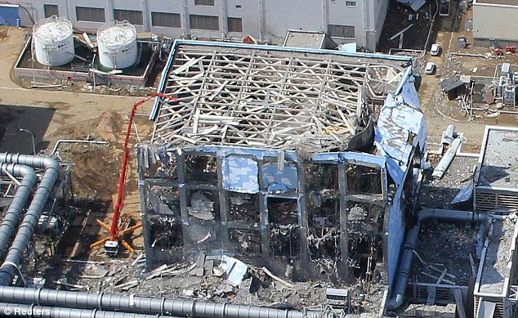

***‘Japanese Nuclear disaster’***



***‘Police Corruption or misconduct’***



# *‘Recession’*



# *‘Police scandals such as links to phone hacking’*

# Corruption Misconduct

# The IPCC

* Main Content
* The IPCC was established by the Police Reform Act and became operational in April 2004.
* Its primary statutory purpose is to increase public confidence in the police complaints system in England and Wales.
* The IPCC also investigates the *most serious* complaints and allegations of misconduct against the police in England and Wales.
* It also handles appeals from people who are not satisfied with the way police have dealt with their complaint.
* The IPCC is independent, making its decisions entirely independently of the police, government and complainants.
* The IPCC is overseen by a Chair, 10 operational Commissioners and 2 non-executive Commissioners.
* The Chair and Commissioners must not have worked for the police in any capacity prior to their appointment.
* The Commission is supported by a Chief Executive who leads a staff of around 400 people.

**The managers of the police officers involved**

* for less serious allegations (e.g. free drinks or food from local café)
* investigated by a sergeant or Inspector.
* investigation unlikely to lead to more than sifting through easily available evidence.
* may involve a verbal reprimand or remedial training.

**Specialist anti-corruption officers within the police officer’s own force**

* dealing with cases ranging from less serious to very serious.
* may conduct an overt investigation where the suspects are informed that they are under investigation. May conduct covert / undercover investigations.
* able to use surveillance, informants, bug telephones, cars and buildings, arrest officers and interview them.

**Specialist anti-corruption officers from outside the police officer’s force**

* for cases where there may be a conspiracy or need for active covert surveillance – a need for outside involvement to protect the investigation.
* Abilities the same as above: specialist officers able to conduct covert surveillance around the clock. May involve direct surveillance – officers following suspected corrupt officers. Many involve ‘bugging’ cars or buildings. May involve undercover informants.

**An independent organisation from outside the police**

* conducted by non-police officers independent from the police service.
* unlikely to involve covert surveillance, bugs and informants. More likely to involve interviews and collection of paper and electronic evidence.
* in the past have looked at cases involving fraud, leaking of information to media and organised criminals.

Stimulus for sorting exercise:

A police officer falsifies evidence against someone thought to be guilty of murder (for example to strengthen the case).

A police officer receives money from a criminal for information on an investigation.

A police officer gives a neighbour unauthorised information about sex offenders living in the local area.

A police officer receives money from a journalist for providing details of an criminal investigation

A police officer offers to drop a charge against a woman if she agrees to have sex with him.

A police officer encourages an offender to admit to crimes that he/she may not have committed using coercive techniques (eg prisoner let out of prison to meet with police officers, where they are given drugs in exchange for a confession)

A senior police officer employs a relative without following recruitment procedures.

Two off duty police officers receive free entry to a nightclub because they say that they are members of the police.

An off-duty police officer regularly uses his warrant card for free entry to sporting events

A police officer sells the drugs he has taken from someone he has arrested

A police officer falsifies figures to improve her teams’ performance, or falsifies the number of people arrested for violent offences for a local news story

A police officer submits a false expenses claim totalling £100.

A police officer checks the national criminal record database to check to see if individuals who want to rent his flat have any previous convictions

A police officer regularly receives free food and drink from a café.

An officer attends a meeting held by another organisation. A free lunch is provided.

During a raid on a house a police officer kicks someone who is under arrest in the head while they are held down by another officer.

**Stimulus to be used to focus on ‘seriousness’:**

A police officer receives money from a criminal for information on an investigation.

A police officer sells the drugs he has taken from someone he has arrested

A police officer falsifies evidence against someone thought to be guilty of murder (for example to strengthen the case).

A police officer submits a false expenses claim totalling £100.

A police officer falsifies figures to improve her teams’ performance, or falsifies the number of people arrested for violent offences for a local news story

An off-duty police officer regularly uses his warrant card for free entry to sporting events

**Priorities**

Patrolling the local area

Investigating burglaries

Policing the roads

Investigating police corruption

Preventing terrorism

**Stimulus document – moderator cribsheet**

**What is corruption?**

**Association of Chief Police Officers’ Definition**: this defines corruption as: ‘*the abuse of one’s role or position held in the service for personal gain or gain for others.*’ The ACPO Counter Corruption Advisory Group (ACCAG) refers to “*any activity carried out by an individual for gain, favour, advancement or reward that is inconsistent with the proper practice of their office, employment or responsibility*.”

***Perverting the Course of Justice:*** *Includes falsification of records, perjury, tampering with evidence. Does not include allegations of disparate treatment of an individual on the basis of: their race, a disability, their gender, sexual orientation, their religion or beliefs, or their age if there is no evidence of any of the above.*

Examples:

* A police officer falsifies evidence against someone thought to be guilty of murder (for example to strengthen the case).

***Unauthorised Disclosure:*** *includes the disclosure of personal details of offenders, suspects or civilians; crime report information; or information that could jeopardise a court case.*

Examples:

* A police officer receives money from a criminal for information on an investigation.
* A police officer gives a neighbour unauthorised information about sex offenders living in the local area.
* A police officer receives money from a journalist for providing details of an criminal investigation

***Abuse of Authority:*** *includes the abuse of the trust or the rights of a colleague or civilian and the misuse of police power and authority for organisational or personal gain, of self or of others. We have included cases of consensual or non-consensual sexual contact with a vulnerable individual where the contact was initiated as part of professional conduct. For example: an officer responding to a domestic violence incident initiates a relationship with a vulnerable female. Or a PCSO on a school liaison visit exchanges contact details which leads to a relationship with a 15 year old girl. Does not include cases of consensual or non-consensual sexual contact between officers while on duty. Does not include alleged sexual abuse / rape of an individual by a serving officer whilst off duty e.g. an officer abusing children who were known through a voluntary position as a scout leader or known through familial / friendships (please see above exceptions). Does not include alleged inappropriate sexual contact during a strip search.*

Examples:

* A police officer offers to drop a charge against a woman if she agrees to have sex with him.
* A police officer encourages an offender to admit to crimes that he/she may not have committed using coercive techniques (eg prisoner let out of prison to meet with police officers, where they are given drugs in exchange for a confession)
* A senior police officer employs a relative without following recruitment procedures.
* Two off duty police officers receive free entry to a nightclub because they are say that they are members of the police.

***Theft and Fraud:*** *includes theft, while on duty, of property, including money, and/or of seized items, including drugs. We have included fraudulent expense or overtime claims. We have included unauthorised personal use of police credit cards. We have not included fraudulent behaviour outside of professional conduct e.g. fraudulent business ventures / benefit claims. We have not included theft, while on or off duty, of items outside of professional duty e.g. allegations of theft of items from a supermarket while on duty. We have not included fraudulent use of own or others (non police-related) credit card.*

Examples:

* A police officer sells the drugs he has taken from someone he has arrested
* A police officer falsifies figures to improve her teams’ performance, or falsifies the number of people arrested for violent offences for a local news story
* A police officer submits a false expenses claim totalling £100.

***Misuse of Systems:*** *we have included the unauthorised access of police systems for personal gain, such as searching police databases for details of vulnerable females or information relating to known third parties, including on behalf of friends or family.*

Examples:

* A police officer checks the national criminal record database to check to see if individuals who want to rent his flat have any previous convictions

**Grey areas and misconduct**

* A police officer regularly receives free food and drink from a café. (this is a grey area as whether it is corruption or not could depend on context/who is providing the free food and drink eg media, criminal etc)
* An officer attends a meeting held by another organisation. A free lunch is provided. (this is not corruption, but we should explore circumstances here eg hospitality, who is giving, what they receive, alcohol)
* During a raid on a house a police officer kicks someone who is under arrest in the head while they are held down by another officer.